**Story**

**Story**

**Puss in Boots**

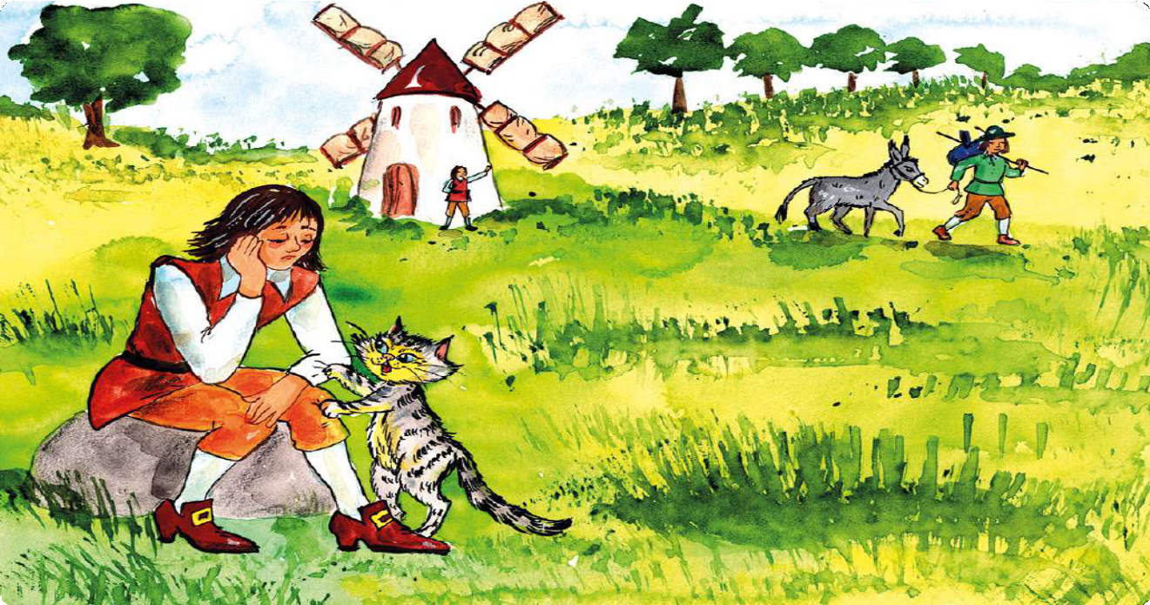

***Read, look at the pictures and answer the questions.***

# Cristian and his two older brothers are the sons of an old miller. When their father dies, he leaves his mill to the oldest son and his donkey to the second one. Cristian, the miller’s favourite son, gets his father’s cat.

I’ll use this donkey for my transport business.

This mill will make me rich.

Don’t worry, master,

I will help you. But first you must buy me a pair of boots and a bag.

I can’t earn money with a cat. And my brothers have abandoned me.

## 

## 1

1. Cristian is the miller’s … son.
   1. oldest **B)** youngest **C)** middle **D)** only
2. Cristian is sad because …
   1. his father hasn’t left him anything. **B)** he doesn’t like the cat.

**C)** the cat can’t help him make money. **D)** his brothers stole his father’s gift from him.

1. Which of the following is not true about the cat?
   1. He can talk. **B)** He wants boots and a bag.

**C)** He doesn’t want to stay with Cristian. **D)** He is willing to help his master.

Cristian is so surprised to hear the cat talk that he spends the little money he has to buy Puss a smart pair of boots and a nice bag.

**Story**

Thank you, master. Now it’s time for me to get to work.

## 2

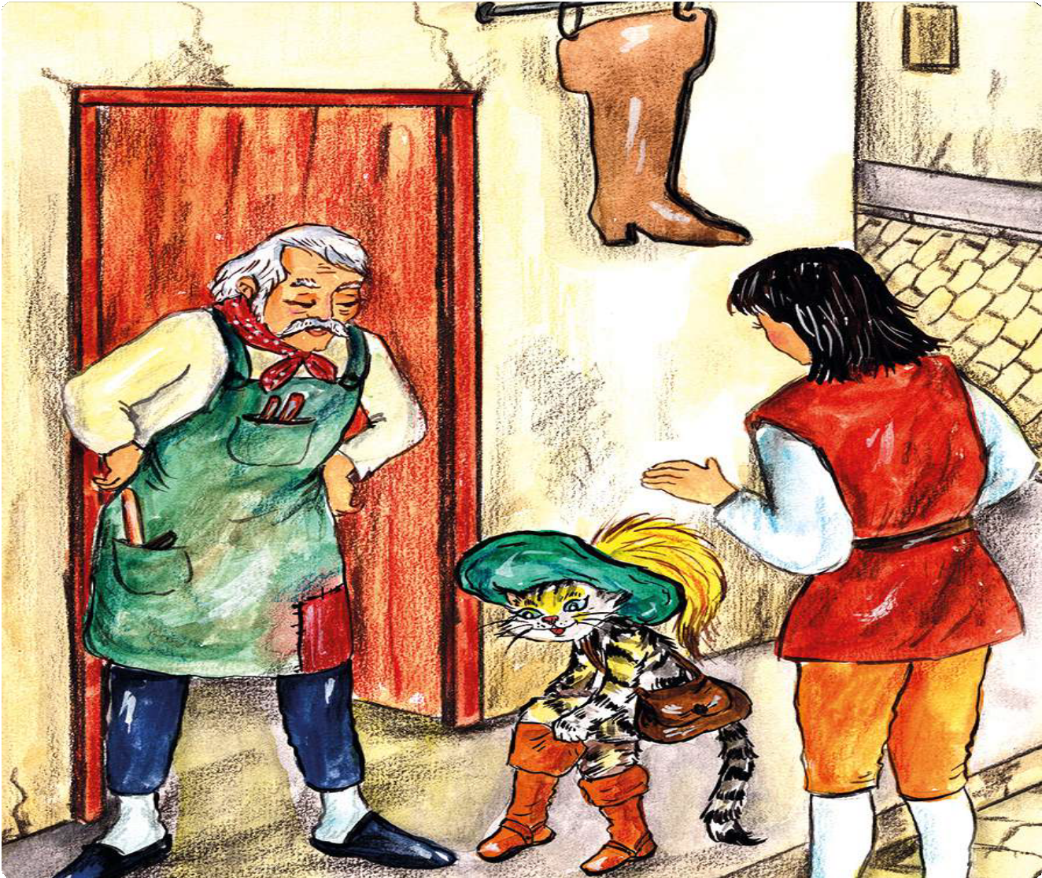

1. Look at the picture. Cristian and Puss are at the … shop.
   1. butcher’s **B)** shoemaker’s **C)** tailor’s **D)** baker’s
2. In the picture, Puss is putting … his new boots.
   1. by **B)** up **C)** on **D)** in

# Puss goes off to the nearby rabbit hole. He traps a fine, young rabbit in his bag and takes it to the palace.

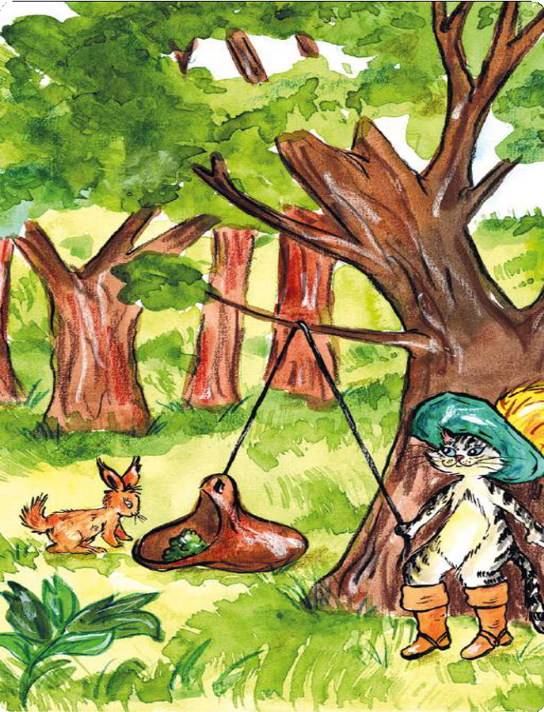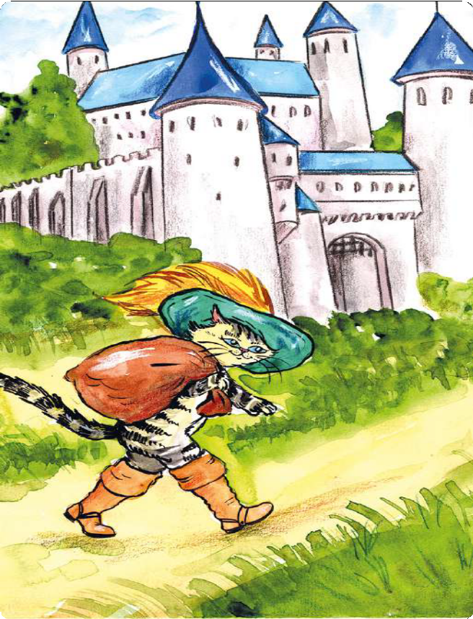

**Story**

Yes, little rabbit, come get that lettuce.

It’s time to see the king.

## 

**3 4**

1. Look at picture 3. Puss uses a … as bait to trap the rabbit.
   1. rope **B)** vegetable **C)** boot **D)** bag
2. Puss is wearing a green hat with yellow … on it.
   1. strings **B)** tails **C)** feathers **D)** bows
3. In picture 4, Puss is taking … to the palace.
   1. the rabbit **B)** the lettuce **C)** Cristian **D)** the king

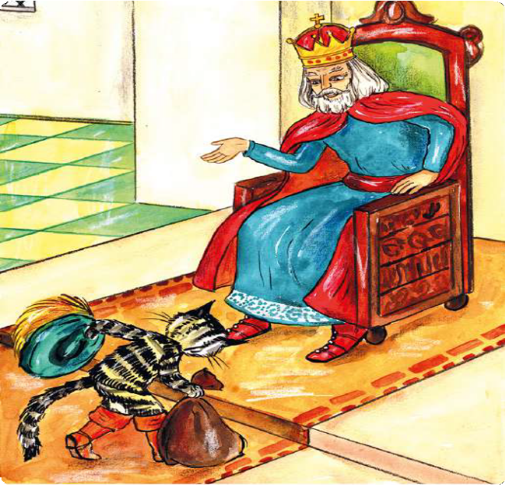

Puss knocks on the palace door and says that he has a present for the king. The guards let him in.

1. Look at the picture. Puss is bowing to the king to show …

My lord Marquis of Carrabas sends this rabbit   
to your Majesty with his respects.

* 1. anger. **B)** respect.

**C)** sadness. **D)** fear.

I accept the gift.

Please give my thanks to the Marquis.

1. Puss says that the present is from the Marquis of Carrabas. A Marquis is a …

**Story**

* 1. nobleman. **B)** politician.

**C)** policeman. **D)** prince.

1. The king is … with the present.
   1. unhappy **B)** pleased

**C)** angry **D)** bored



The king orders his chef to cook the rabbit for dinner. It is delicious. Puss brings the king a gift every day after that.

**5**

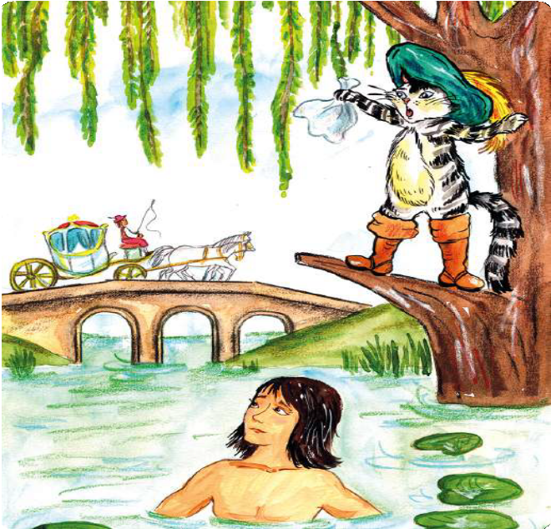

Now, Puss asks Cristian to go bathing in the river. When he does, Puss hides all his clothes and begins shouting. Just then, the king’s carriage passes on the bridge.

Help! My master, the Marquis of Carrabas,

has lost all his clothes.

1. Look at picture 6. Puss is …
   1. singing. **B)** screaming.

**C)** dancing. **D)** running.

1. How does Cristian lose his clothes?
   1. A stranger steals them.
   2. They go down in the river.
   3. Puss hides them.
   4. He forgets where he put them.



**6**

The king hears the Marquis’s name and orders his servant to fetch one of his own suits from the palace.

**Story**

After getting dressed, Cristian thanks the king for the clothes. The king introduces Cristian to his beautiful daughter and offers him a ride home in his carriage.

1. The king thinks that Cristian is …

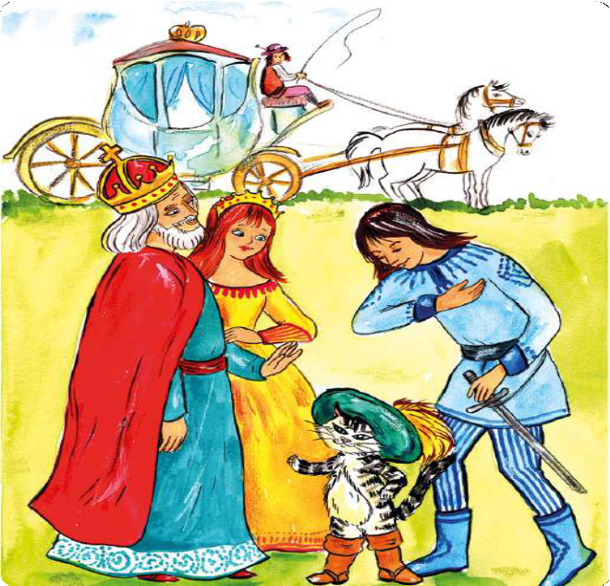

**7**

Marquis, my daughter and I want to thank you for all your delicious gifts.

It was my pleasure, your Majesty. Thank you for offering me a lift home.

* 1. the Marquis of Carrabas.
  2. a knight.
  3. a miller’s son.
  4. a rabbit hunter.

1. Cristian is holding … in his left hand.
   1. a rod
   2. an arrow
   3. a sword
   4. a stick

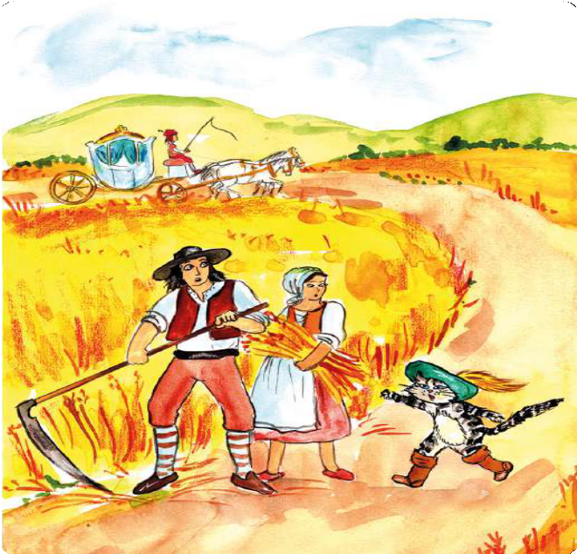

Puss runs ahead and meets some farmers. He convinces them to tell the king that the whole land belongs to the Marquis of Carrabas. The king is impressed with the property.

Okay, we will do as you say.

But don’t forget your promise of a reward.

1. Puss asks the farmers to tell the king that…
   1. Cristian is the Marquis of Carrabas.
   2. the land belongs to the Marquis of Carrabas.
   3. Puss is the owner of the farm.
   4. Cristian is the son of the Marquis of Carrabas.
2. The farmers agree to do what Puss says because …
   1. Puss threatens to kill them.
   2. Puss promises to give them a reward.
   3. they are scared of a talking cat.

**8**

* 1. they are afraid of the Marquis.

Your great Ogreship,   
I’d be honored to see your  
power in action.

**Story**

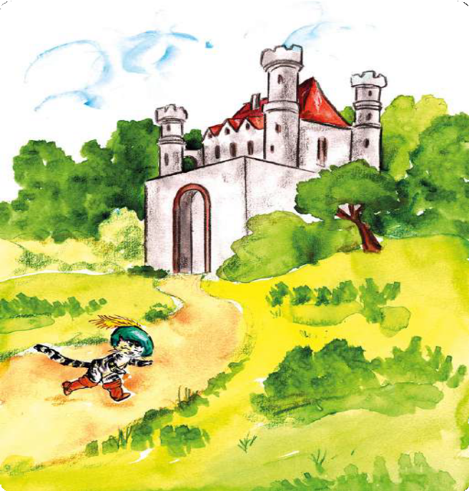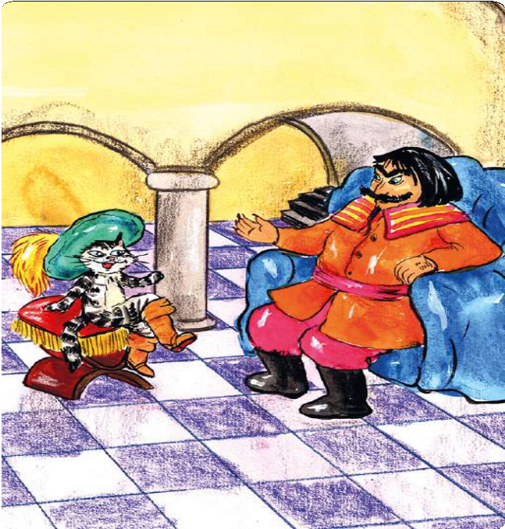

Puss keeps running and stops at a castle. It belongs to an ogre who eats human children. Puss meets the ogre, praises him for his strength, cleverness and the power to turn himself into any creature he wishes.

**9**

**10**

Very well.   
I will show you how it works.

1. Who lives in the castle?
   1. A man-eating giant. **B)** A fire-breathing dragon.

**C)** An evil dwarf. **D)** A two-headed monster.

1. Puss is not afraid to meet the ogre because …
   1. the ogre is a peaceful and kind creature.
   2. Puss has magic powers.
   3. Puss is very courageous.
   4. Puss promises to bring him human children.
2. What special power does the ogre have?
   1. He can turn anybody into an ogre.
   2. He can turn animals into human children.
   3. He can turn himself into other creatures.
   4. He can turn humans into animals.

# The ogre loves compliments and showing off. He turns himself into a giant roaring lion. Puss asks the ogre if he can become a smaller animal, like a mouse. The ogre laughs and becomes a rat. Puss kills him.

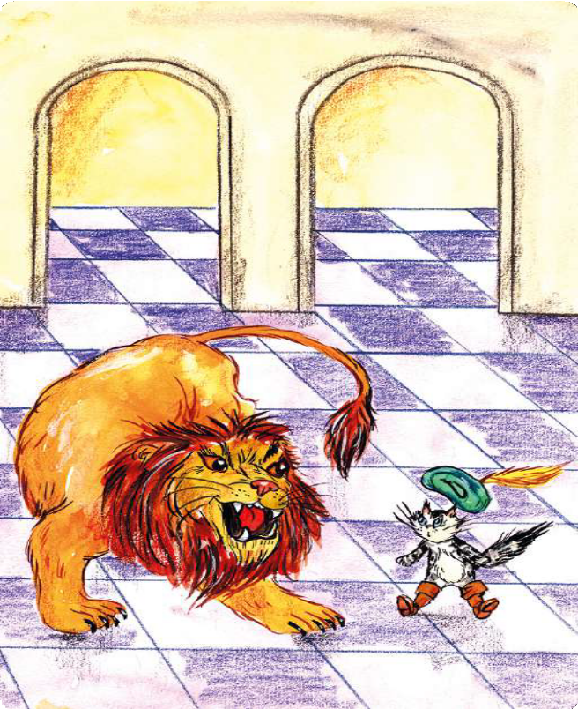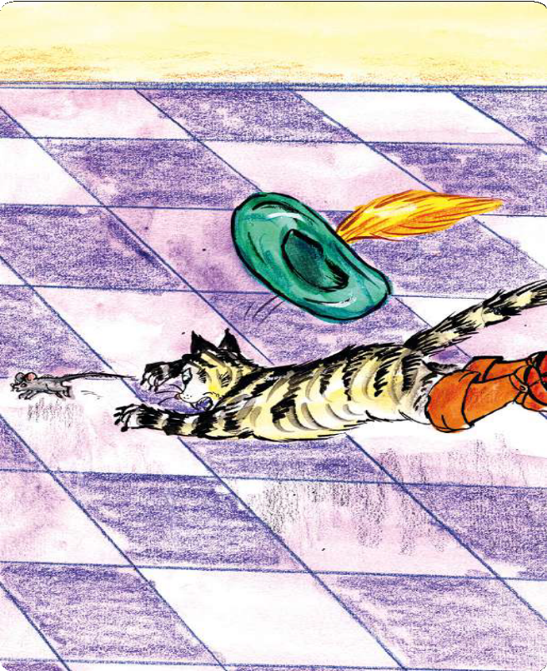

**Story**

Wow! That’s impressive!

=

Die, you mean ogre! Now this castle belongs to my master. And the children will be safe.

## 

**11 12**

1. The ogre turns himself into a lion to …
   1. kill Puss. **B)** prove his power. **C)** go hunting. **D)** scare the cat.
2. Puss … the ogre into becoming a mouse and kills him.
   1. trips **B)** tries **C)** tricks **D)** turns
3. The ogre loses his life because he is …
   1. proud and stupid. **B)** wise and brave.

**C)** courageous and smart. **D)** clever and strong.

I offer the Marquis

of Carrabas my daughter’s

hand in marriage.

**Story**

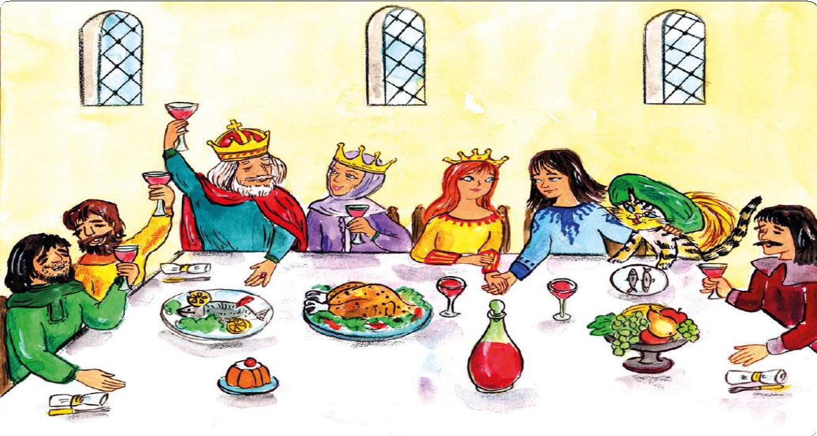

The king’s carriage arrives at the castle. They all enjoy a great big feast. The king and the queen are very pleased with Cristian and invite him to their court.

each other.

**13**

like

I can see that the Marquis and the princess

i

1. Who does the castle belong to now?
   1. The ogre. **B)** The king. **C)** Puss. **D)** Cristian.
2. The king wants …
   1. the castle for himself.
   2. Cristian to live in his court.
   3. Cristian to marry the princess.
   4. to take Puss with him.
3. Look at the picture. How many glasses of wine can you see?
   1. Seven. **B)** Eight. **C)** Six. **D)** Five.

# At the palace, Cristian gets married to the princess, with the king’s blessings. They live happily ever after in their castle, with Puss always by their side.

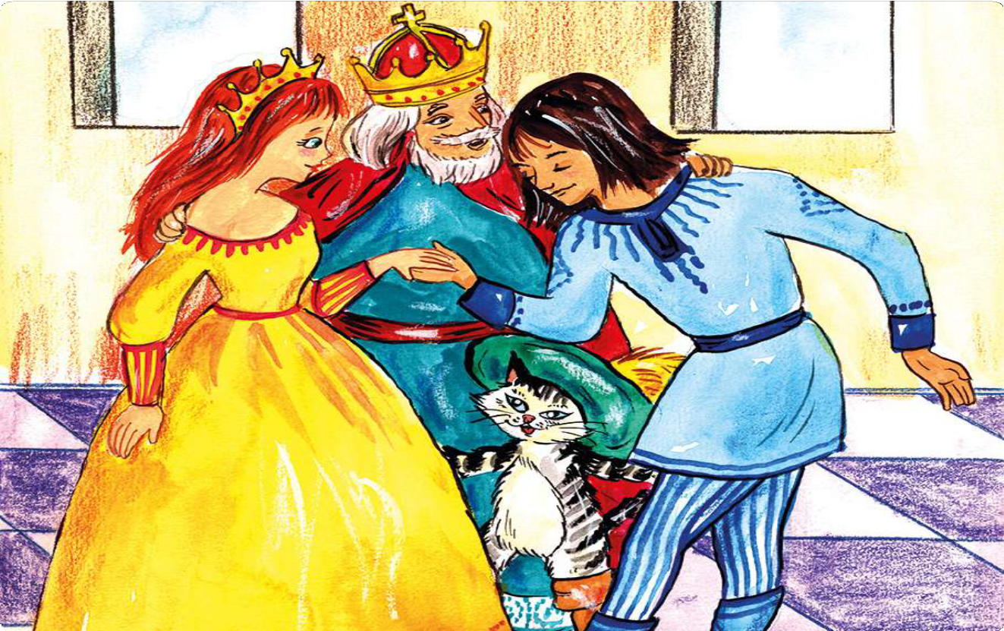

**Story**

## 14

1. Cristian marries the princess and becomes …
   1. the king. **B)** a miller. **C)** an ogre. **D)** a prince.
2. Cristian, the princess and Puss live happily …
   1. on the farm. **B)** in the castle. **C)** in the palace. **D)** at the court.
3. In the end, Puss … his promise to Cristian.
   1. breaks **B)** forgets **C)** gives **D)** keeps
4. What is the moral of the story?
   1. Cats are clever animals. **B)** Even a small gift can prove highly precious.

**C)** Good boots are the key to success. **D)** Flattery will get you everywhere.